Activity-Based Learning (ABL):
Experiment -1. University Scholarship Allocation:
1. Problem Statement:
University Scholarship Allocation: Design a system that evaluates applicants on subject-wise minimum scores, attendance, and ranks eligible students based on the criteria.
2.objectives:
1.To check students' scholarship eligibility.
2.To verify marks, attendance, and family income.
3.To identify eligible students based on the given criteria.
4.To rank eligible students according to their marks.
3. Assumptions:
The minimum aggregate marks required are 80%, with at least 40 marks in each subject. Students must have a minimum attendance of 75%, and their family annual income must not exceed ₹3,00,000. Students with higher aggregate marks receive higher ranks. If no student is eligible, the system displays "No eligible students".
4.Algorithm:
- Start.
- Input the number of applicants.
- Input marks, attendance, and family income.
- Check the eligibility criteria.
- Rank eligible students based on aggregate marks.
- Display the result
- End.
5. Pseudocode:
BEGIN
INPUT marks, attendance, income
IF marks >= 80 AND attendance >= 75
AND income <= 300000
PRINT "Eligible"
ELSE
PRINT "Not Eligible"

Display result
STOP
6.Flowchart: Start → Input applicant details → Check subject marks, aggregate, attendance and income → Check eligibility → Rank eligible students → Display results → End
7.Program code:
# University Scholarship Allocation
marks = float(input("Enter aggregate marks (%): "))
subject1 = float(input("Enter marks in Subject 1: "))
subject2 = float(input("Enter marks in Subject 2: "))
attendance = float(input("Enter attendance percentage: "))
income = float(input("Enter annual family income (Rs.): "))
if (marks >= 80 and subject1 >= 40 and subject2 >= 40
and attendance >= 75 and income <= 300000):
print("Student is Eligible for Scholarship")
else:
print("Student is Not Eligible for Scholarship"
8.Test Cases:
Test Case | Input | Expected Output
1 | Marks: 85%, Attendance: 90%, Income: ₹2,00,000, Subjects: 80, 90 | Eligible
2 | Marks: 75%, Attendance: 90%, Income: ₹2,00,000, Subjects: 80, 85 | Not Eligible
3 | Marks: 85%, Attendance: 70%, Income: ₹2,00,000, Subjects: 80, 90 | Not Eligible
4 | Marks: 85%, Attendance: 90%, Income: ₹4,00,000, Subjects: 80, 90 | Not Eligible
5 | Marks: 85%, Attendance: 90%, Income: ₹2,00,000, Subjects: 35, 90 | Not Eligible

9.Sample Output:
Test Case 1: Eligible Student
Enter aggregate marks (%): 85
Enter marks in Subject 1: 80
Enter marks in Subject 2: 90
Enter attendance percentage: 90
Enter annual family income (Rs.): 200000
Student is Eligible for Scholarship
Test Case 2: Marks Below 80%
Enter aggregate marks (%): 75
Enter marks in Subject 1: 80
Enter marks in Subject 2: 85
Enter attendance percentage: 90
Enter annual family income (Rs.): 200000
Student is Not Eligible for Scholarship
Test Case 3: Attendance Below 75%
Enter aggregate marks (%): 85
Enter marks in Subject 1: 80
Enter marks in Subject 2: 90
Enter attendance percentage: 70
Enter annual family income (Rs.): 200000
Student is Not Eligible for Scholarship
Test Case 4: Family Income Above ₹3,00,000
Enter aggregate marks (%): 85
Enter marks in Subject 1: 80
Enter marks in Subject 2: 90
Enter attendance percentage: 90
Enter annual family income (Rs.): 400000
Student is Not Eligible for Scholarship
Test Case 5: Subject Marks Below 40
Enter aggregate marks (%): 85
Enter marks in Subject 1: 35
Enter marks in Subject 2: 90
Enter attendance percentage: 90
Enter annual family income (Rs.): 200000
Student is Not Eligible for Scholarship
10:Actual Output:
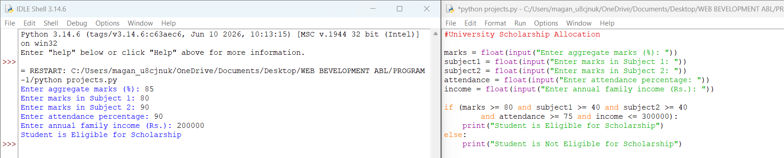
11.Conclusion:
Thus, the University Scholarship Allocation program was successfully developed using Python. It checks students' marks, attendance, and family income to determine scholarship eligibility. The program helps identify eligible students based on the given criteria.

Experiment -2.Employee Payroll and Deduction Analysis:
1. Problem Statement:
Calculate gross salary from basic pay, allowances, overtime, and incentives; apply progressive deductions and generate a formatted salary statement.
2. Objectives:
- To calculate the gross salary of an employee.
- To calculate deductions based on salary.
- To determine the net salary.
- To generate a formatted salary statement.
3. Assumptions:
The basic pay, allowances, overtime, and incentives are entered by the user. Gross salary is calculated by adding all earnings. Deductions are applied according to the salary amount, and net salary is calculated by subtracting total deductions from gross salary.
4. Algorithm:
- Start.
- Input basic pay, allowances, overtime, and incentives.
- Calculate gross salary.
- Calculate progressive deductions.
- Calculate net salary.
- Display the formatted salary statement.
- Stop.
5. Pseudocode:
START
INPUT basic pay, allowances, overtime, incentives
gross salary = basic pay + allowances + overtime + incentives
CALCULATE deductions
net salary = gross salary - deductions
DISPLAY salary statement
END
6.Flowchart: Start → Input employee details → Calculate gross salary → Calculate progressive deductions → Calculate net salary → Display salary statement → Stop.
7.Program code:
# Employee Payroll and Deduction Analysis
name = input("Enter employee name: ")
basic = float(input("Enter basic pay: "))
allowances = float(input("Enter allowances: "))
overtime = float(input("Enter overtime amount: "))
incentives = float(input("Enter incentives: "))
gross = basic + allowances + overtime + incentives
# Progressive deduction rates
if gross <= 20000:
deduction = gross * 0.05
elif gross <= 50000:
deduction = gross * 0.10
else:
deduction = gross * 0.15
net = gross - deduction
print("\n------ SALARY STATEMENT ------")
print("Employee Name :",name)
print("Basic Pay :",basic)
print("Allowances :",allowances)
print("Overtime :",overtime)
print("Incentives :",incentives)
print("Gross Salary :",gross)
print("Deduction :",deduction)
print("Net Salary :",net)
8.Test Cases:
Test Case | Gross Salary | Deduction Rate | Expected Result
1 | ₹18,000 | 5% | Net salary: ₹17,100
2 | ₹35,000 | 10% | Net salary: ₹31,500
3 | ₹60,000 | 15% | Net salary: ₹51,000
9.Sample Output:
Enter employee name: Ravi
Enter basic pay: 30000
Enter allowances: 5000
Enter overtime amount: 2000
Enter incentives: 3000
SALARY STATEMENT
Employee Name : Ravi
Basic Pay : ₹ 30000.0
Allowances : ₹ 5000.0
Overtime : ₹ 2000.0
Incentives : ₹ 3000.0
Gross Salary : ₹ 40000.0
Deduction : ₹ 4000.0
Net Salary : ₹ 36000.0
10:Actual Output:
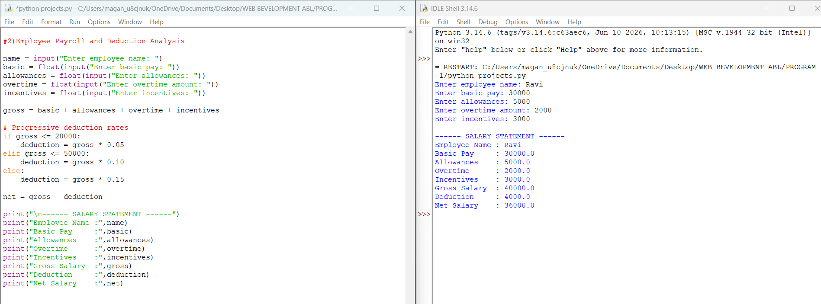
11. Conclusion
The Employee Payroll and Deduction Analysis program was successfully developed using Python. It calculates gross salary, applies progressive deductions, and displays the employee's net salary in a formatted salary statement.

Experiment 3: Multi-Event Sports Scheduling and Scoring
1. Problem Statement:
To develop a Python program that represents sports event schedules and team scores using lists and tuples, identifies scheduling conflicts, calculates total points, and generates final team rankings.
2. Objectives:
- To store event schedules using lists and tuples.
- To identify scheduling conflicts between events.
- To calculate the total points scored by each team.
- To rank teams based on their total points.
3. Assumptions:
Each sports event has a name, time, and participating teams. Events scheduled at the same time are considered conflicts. Teams receive points based on their performance. The team with the highest total points receives the first rank.
4. Algorithm:
- Start.
- Store sports event schedules using lists and tuples.
- Check for scheduling conflicts.
- Input team scores.
- Calculate total points for each team.
- Sort teams according to total points.
- Display conflicts and final rankings.
- Stop.
5. Pseudocode:
START
STORE event schedules
CHECK scheduling conflicts
STORE team scores
CALCULATE total points
SORT teams by points
DISPLAY conflicts and rankings
END
6. Flowchart in One Line:
Start → Store Event Schedules → Check Scheduling Conflicts → Calculate Team Points → Rank Teams → Display Results → Stop
7. Python Source Code:
# Multi-Event Sports Scheduling and Scoring
events = [
("Cricket", "10:00 AM"),
("Football", "11:00 AM"),
("Basketball", "10:00 AM"),
("Volleyball", "12:00 PM")
]
print("SPORTS EVENT SCHEDULE")
for event in events:
print(event[0], "-", event[1])
print("\nSCHEDULING CONFLICTS")
conflict = False
for i in range(len(events)):
for j in range(i + 1, len(events)):
if events[i][1] == events[j][1]:
print(events[i][0], "and", events[j][0],
"have a scheduling conflict.")
conflict = True
if not conflict:
print("No scheduling conflicts.")
scores = [("Team A", 30), ("Team B", 45),
("Team C", 25), ("Team D", 40)]
scores.sort(key=lambda x: x[1], reverse=True)
print("\nFINAL TEAM RANKINGS")
for rank, team in enumerate(scores, start=1):
print(rank, team[0], "-", team[1], "points")
8. Test Cases:
Test Case | Input Condition | Expected Output
1 | Two events at the same time | Scheduling conflict detected
2 | All events at different times | No scheduling conflicts
3 | Team scores: 30, 45, 25, 40 | Teams ranked by descending points
4 | Team scores are equal | Teams appear in the order retained by the sorting operation
9.Sample Output:
SPORTS EVENT SCHEDULE
Cricket - 10:00 AM
Football - 11:00 AM
Basketball - 10:00 AM
Volleyball - 12:00 PM
SCHEDULING CONFLICTS
Cricket and Basketball have a scheduling conflict.
FINAL TEAM RANKINGS
1 Team B - 45 points
2 Team D - 40 points
3 Team A - 30 points
4 Team C - 25 points
10:Actual Output:
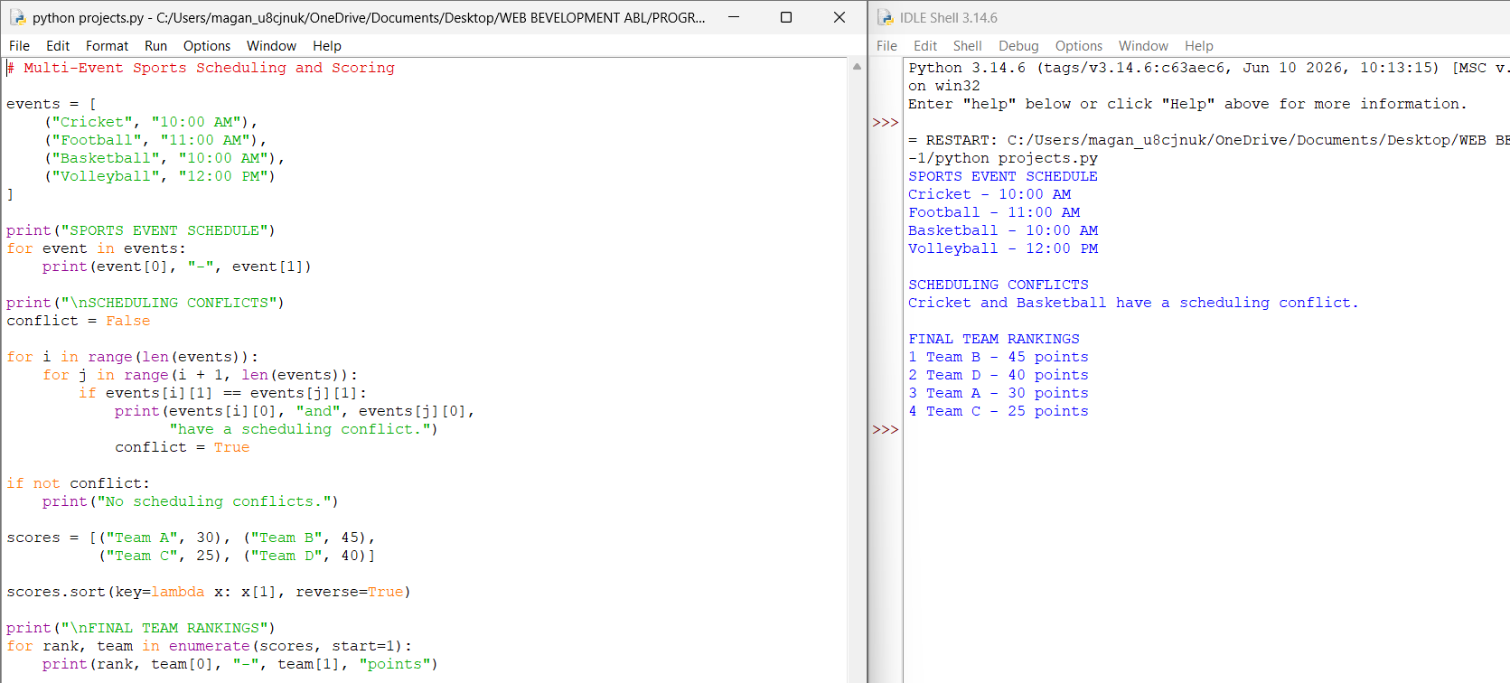
11. Conclusion
Thus, the Multi-Event Sports Scheduling and Scoring program was successfully developed using Python. It identifies scheduling conflicts, calculates team rankings based on points, and displays the results.

Experiment 4: Multi-Stage ATM Transaction Audit
1. Problem Statement:
To develop a Python program that processes deposits, withdrawals, and transfers, maintains account balances, detects invalid transactions, and identifies suspicious repeated transaction patterns.
2. Objectives:
- To process ATM transactions.
- To maintain account balances.
- To detect invalid transactions.
- To identify suspicious repeated patterns.
3. Assumptions:
The account has an initial balance. Deposits increase the balance, while withdrawals and transfers decrease it. Transactions with insufficient funds or invalid amounts are rejected. Repeated withdrawals of the same amount are flagged as suspicious for review.
4. Algorithm:
- Start.
- Input the initial account balance.
- Enter the transaction type and amount.
- Process deposits, withdrawals, and transfers.
- Check for invalid transactions.
- Detect suspicious repeated transactions.
- Display the final balance and transaction report.
- Stop.
5. Pseudocode:
START
INPUT initial balance
PROCESS transactions
IF transaction is valid
UPDATE balance
ELSE
DISPLAY invalid transaction
CHECK repeated transactions
DISPLAY final balance and report
END
6. Flowchart: Start → Input Initial Balance → Process Transactions → Validate Transactions → Update Balance → Detect Suspicious Patterns → Display Transaction Report → Stop
7. Python Source Code:
Python Source Code – ATM Transaction Audit
# Multi-Stage ATM Transaction Audit
balance = float(input("Enter initial balance: "))
transactions = []
withdrawals = []
suspicious = []
n = int(input("Enter number of transactions: "))
for i in range(n):
print("\n1. Deposit 2. Withdrawal 3. Transfer")
choice = int(input("Enter transaction type: "))
amount = float(input("Enter amount: "))
if amount <= 0:
print("Invalid transaction amount")
continue
if choice == 1:
balance += amount
transactions.append(("Deposit", amount))
print("Deposit successful")
elif choice == 2 or choice == 3:
if amount > balance:
print("Invalid transaction: Insufficient balance")
continue
balance -= amount
if choice == 2:
transactions.append(("Withdrawal", amount))
withdrawals.append(amount)
print("Withdrawal successful")
else:
transactions.append(("Transfer", amount))
print("Transfer successful")
else:
print("Invalid transaction type")
# Detect repeated withdrawals
for amount in withdrawals:
if withdrawals.count(amount) > 1 and amount not in suspicious:
suspicious.append(amount)
print("\n----- TRANSACTION REPORT -----")
for transaction in transactions:
print(transaction[0], "- Rs.", transaction[1])
print("Final Balance: Rs.", balance)
if suspicious:
print("Suspicious repeated withdrawals:", suspicious)
else:
print("No suspicious repeated withdrawals detected")
8. Test Cases:
Test Case | Input Condition | Expected Output
1 | Deposit ₹1,000 | Balance increases
2 | Withdraw ₹500 with sufficient funds | Withdrawal successful
3 | Withdraw more than the balance | Insufficient balance
4 | Enter a negative amount | Invalid transaction amount
5 | Repeat withdrawals of the same amount | Suspicious pattern reported
9. Sample Output:
Enter initial balance: 5000
Enter number of transactions: 4
1. Deposit 2. Withdrawal 3. Transfer
Enter transaction type: 1
Enter amount: 1000
Deposit successful
1. Deposit 2. Withdrawal 3. Transfer
Enter transaction type: 2
Enter amount: 500
Withdrawal successful
1. Deposit 2. Withdrawal 3. Transfer
Enter transaction type: 2
Enter amount: 500
Withdrawal successful
1. Deposit 2. Withdrawal 3. Transfer
Enter transaction type: 3
Enter amount: 7000
Invalid transaction: Insufficient balance
----- TRANSACTION REPORT -----
Deposit - Rs. 1000.0
Withdrawal - Rs. 500.0
Withdrawal - Rs. 500.0
Final Balance: Rs. 5000.0
Suspicious repeated withdrawals: [500.0]
10:Actual Output:
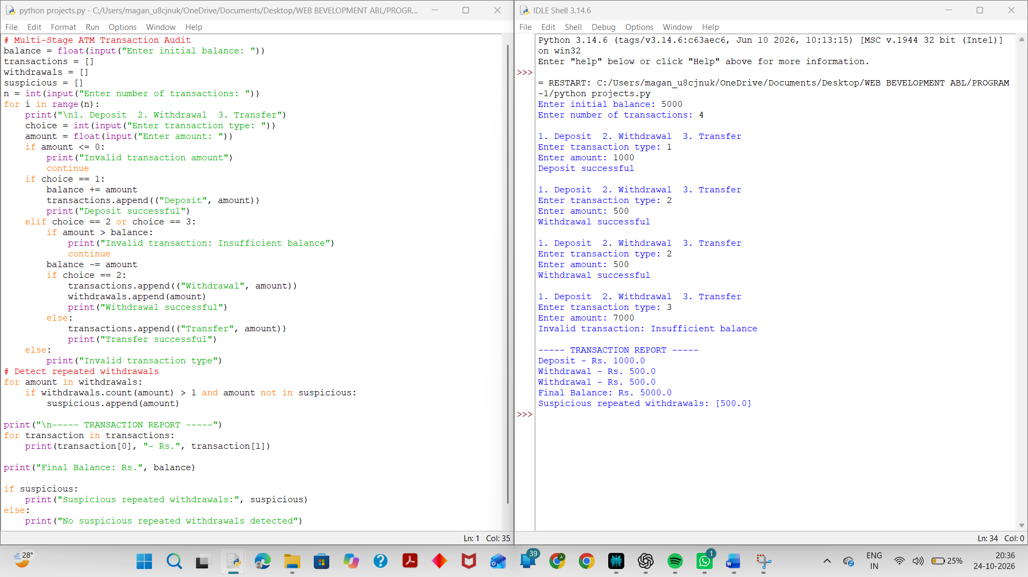
11. Conclusion
Thus, the ATM Transaction Audit program was successfully developed using Python. It processes transactions, updates account balances, detects invalid operations, and reports suspicious repeated withdrawals.

Experiment 5: Hospital Resource Allocation and Capacity Monitoring:
1.Problem Statement:
To develop a Python program that analyses bed occupancy, available staff, and equipment across hospital wards using nested lists, identifies resource shortages, and prioritizes cases based on predefined rules.
2. Objectives:
- To monitor bed occupancy across hospital wards.
- To check staff and equipment availability.
- To identify resource shortages.
- To prioritize cases based on given rules.
3. Assumptions:
Each ward has a fixed number of beds, available staff, and medical equipment. If occupied beds reach the total capacity, the ward is considered full. If staff or equipment availability falls below the required level, a resource shortage is reported. Cases are prioritized according to the priority rules supplied in the program.
4. Algorithm:
- Start.
- Store ward details using nested lists.
- Check bed occupancy and capacity.
- Check staff and equipment availability.
- Identify resource shortages.
- Assign priority to cases.
- Display ward status and priority details.
- Stop.
- Pseudocode:
START
STORE ward details in nested lists
CHECK bed occupancy
CHECK staff and equipment availability
IDENTIFY resource shortages
PRIORITIZE cases
DISPLAY ward status and shortages
END
6. Flowchart in One Line:
Start → Store Ward Details → Check Bed Occupancy → Check Staff and Equipment → Identify Shortages → Prioritize Cases → Display Report → Stop
7.Python Source Code:
# Hospital Resource Allocation and Capacity Monitoring
# Ward: [Name, Total Beds, Occupied Beds, Staff, Equipment]
wards = [
["General", 50, 45, 8, 10],
["ICU", 20, 20, 3, 2],
["Emergency", 30, 25, 4, 3]
]
print("HOSPITAL RESOURCE REPORT")
for ward in wards:
name, total, occupied, staff, equipment = ward
print("\nWard:", name)
print("Available Beds:", total - occupied)
if occupied >= total:
print("Bed Status: Full")
else:
print("Bed Status: Available")
if staff < 5:
print("Staff Shortage")
if equipment < 5:
print("Equipment Shortage")
# Case priority: 1 = High, 2 = Medium, 3 = Low
cases = [
("Patient A", 1),
("Patient B", 3),
("Patient C", 2)
]
cases.sort(key=lambda x: x[1])
print("\nCASE PRIORITY")
for patient, priority in cases:
print(patient, "- Priority", priority)
8. Test Case
Test Case | Condition | Expected Output
1 | Occupied beds equal total beds | Ward is full
2 | Occupied beds are below capacity | Beds are available
3 | Staff count is below 5 | Staff shortage reported
4 | Equipment count is below 5 | Equipment shortage reported
5 | Cases have different priority values | Cases sorted by priority
- Sample Output:
HOSPITAL RESOURCE REPORT
Ward: General
Available Beds: 5
Bed Status: Available
Ward: ICU
Available Beds: 0
Bed Status: Full
Staff Shortage
Equipment Shortage
Ward: Emergency
Available Beds: 5
Bed Status: Available
Staff Shortage
Equipment Shortage
CASE PRIORITY
Patient A - Priority 1
Patient C - Priority 2
Patient B - Priority 3
10:Actual Output:
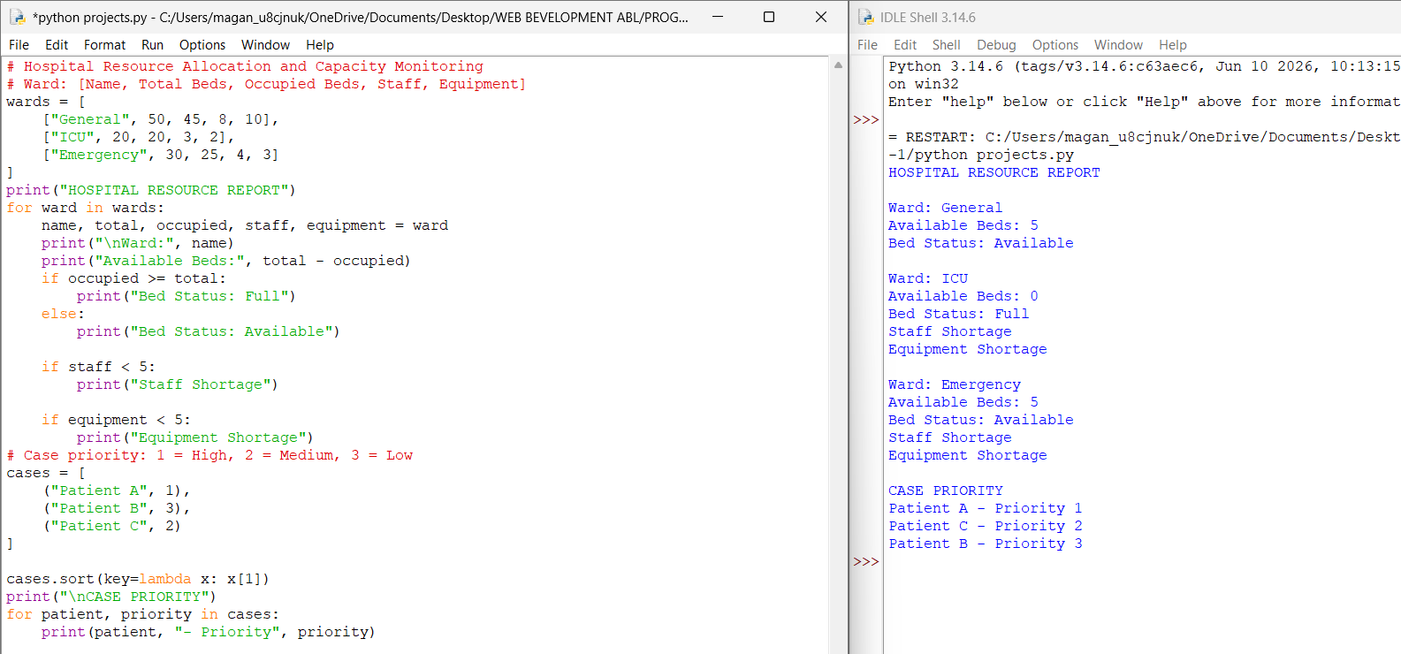
11. Conclusion
Thus, the Hospital Resource Allocation and Capacity Monitoring program was successfully developed using Python. It monitors ward capacity, identifies staff and equipment shortages, and prioritizes cases according to the defined rules.

Experiment 6: Campus Festival Registration and Financial Audit:
1. Problem Statement:
To develop a Python program that reconciles participant registrations, registration fees, sponsorship contributions, and expenses, detects duplicate registrations, and calculates the final financial balance.
2. Objectives:
- To maintain participant registration records.
- To identify duplicate registrations.
- To calculate registration fees and sponsorship contributions.
- To calculate total expenses and final financial balance.
3. Assumptions:
Each participant has a unique name. Repeated names are treated as duplicate registrations for this simple example. Registration fees and sponsorship contributions are added to the total income. Expenses are subtracted from the total income to calculate the final financial balance.
4. Algorithm:
- Start.
- Store participant registration details.
- Identify duplicate registrations.
- Calculate total registration fees.
- Calculate total sponsorship contributions.
- Calculate total expenses.
- Calculate the final financial balance.
- Display the audit report.
- Stop.
5.Pseudocode:
START
INPUT participant details
IDENTIFY duplicate registrations
CALCULATE registration fees
CALCULATE sponsorship contributions
CALCULATE total expenses
BALANCE = TOTAL INCOME - TOTAL EXPENSES
DISPLAY financial report
END
6. Flowchart in One Line:
Start → Store Registrations → Detect Duplicates → Calculate Total Income → Calculate Expenses → Calculate Final Balance → Display Audit Report → Stop.
6.Python Source Code:
# Campus Festival Registration and Financial Audit
participants = ["Amrutha", "Ravi", "Sita", "Ravi"]
fee = 500
sponsorships = [5000, 3000]
expenses = [4000, 2000, 1500]
print("CAMPUS FESTIVAL AUDIT REPORT")
unique_participants = list(set(participants))
duplicates = []
for name in participants:
if participants.count(name) > 1 and name not in duplicates:
duplicates.append(name)
print("\nParticipant List:", participants)
print("Duplicate Registrations:", duplicates)
total_fees = len(unique_participants) * fee
total_sponsorship = sum(sponsorships)
total_expenses = sum(expenses)
total_income = total_fees + total_sponsorship
balance = total_income - total_expenses
print("\nTotal Registration Fees: Rs.", total_fees)
print("Total Sponsorship: Rs.", total_sponsorship)
print("Total Income: Rs.", total_income)
print("Total Expenses: Rs.", total_expenses)
print("Final Financial Balance: Rs.", balance)
8. Test Cases:
Test Case | Condition | Expected Output
1 | All participant names are unique | No duplicates
2 | A participant name is repeated | Duplicate detected
3 | Income is greater than expenses | Positive balance
4 | Expenses are greater than income | Negative balance
5 | Income equals expenses | Zero balance
9. Sample Output:
CAMPUS FESTIVAL AUDIT REPORT
participants = ["Amrutha", "Ganavi", "Veda", "Srija"]
Duplicate Registrations: ['Ravi']
Total Registration Fees: Rs. 1500
Total Sponsorship: Rs. 8000
Total Income: Rs. 9500
Total Expenses: Rs. 7500
Final Financial Balance: Rs. 2000
10:Actual Output:
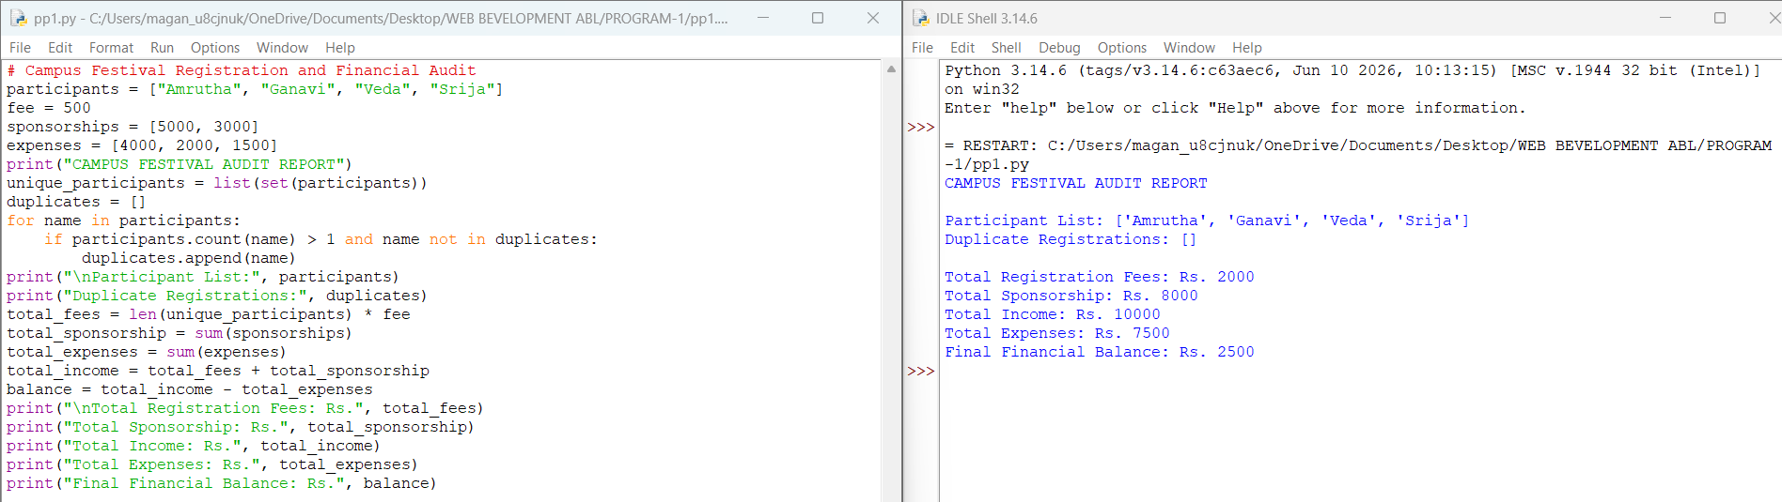
11. Conclusion:
Thus, the Campus Festival Registration and Financial Audit program was successfully developed using Python. It identifies duplicate registrations, calculates total income and expenses, and displays the final financial balance.

Experiment 7: Student Timetable Conflict Detection:
1. Problem Statement:
To develop a Python program that compares course schedules using strings and tuples, detects overlapping periods, identifies unavailable rooms, and validates a proposed timetable.
2. Objectives:
- To store course schedules using strings and tuples.
- To detect overlapping class periods.
- To identify unavailable classrooms.
- To validate the proposed timetable.
3. Assumptions:
Each course has a course name, time, and classroom. Two courses scheduled at the same time in the same classroom create a conflict. A classroom marked as unavailable cannot be used for a class.
4. Algorithm:
- Start.
- Store course schedules using tuples.
- Store unavailable classrooms.
- Compare course timings.
- Detect overlapping periods.
- Check classroom availability.
- Display timetable validation results.
- Stop.
5.Pseudocode:
START
STORE course schedules
CHECK overlapping periods
CHECK room availability
IF conflicts exist
DISPLAY conflicts
ELSE
DISPLAY timetable is valid
Display the timetable validation result
END
6. Flowchart in One Line: Start → Store Course Schedules → Check Time Conflicts → Check Room Availability → Validate Timetable → Display Results → Stop
7.Python Source Code:
# Student Timetable Conflict Detection
# Each tuple contains course, time, and room
courses = [
("Python", "09:00-10:00", "Room A"),
("HTML", "09:00-10:00", "Room B"),
("Maths", "10:00-11:00", "Room A"),
("English", "11:00-12:00", "Room C")
]
unavailable_rooms = ["Room C"]
print("STUDENT TIMETABLE")
for course in courses:
print(course)
print("\nCONFLICT REPORT")
8. Test Cases
Test Case | Input / Condition | Expected Output
1 | Two courses overlap in time | Timetable conflict detected
2 | Two courses have different time periods | No time conflict
3 | Two courses overlap in the same room | Room conflict detected
4 | A course is scheduled in an unavailable room | Unavailable room reported
5 | No conflicts and all rooms are available | Timetable is valid
9.Sample Output:
STUDENT TIMETABLE
('Python', '09:00-10:00', 'Room A')
('HTML', '09:00-10:00', 'Room B')
('Maths', '10:00-11:00', 'Room A')
('English', '11:00-12:00', 'Room C')
CONFLICT REPORT
Python and HTML have overlapping class timings.
Room C is unavailable for English.
Timetable is INVALID.
10:Actual Output:
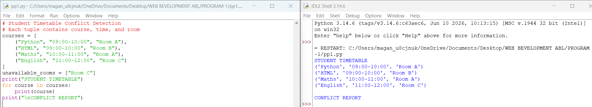
11. Conclusion:
Thus, the Student Timetable Conflict Detection program was developed successfully using Python. It helps identify overlapping class timings, detect unavailable classrooms, and validate the proposed timetable. This program helps reduce scheduling conflicts and supports effective timetable management.

Experiment 8: String-Based Examination Answer Evaluation:
1. Problem Statement:
To develop a Python program that compares student answers with an answer key, calculates correct, incorrect, and unanswered responses, applies negative marking, and produces student-wise results.
2. Objectives:
- To compare student answers with the answer key using strings.
- To calculate the number of correct, incorrect, and unanswered questions.
- To apply negative marking for incorrect answers.
- To calculate the final score of each student.
- To display student-wise examination results.
3. Assumptions:
- Each correct answer carries 1 mark.
- Each incorrect answer carries a penalty of 0.25 marks.
- Unanswered questions carry 0 marks.
- Student answers are compared with the answer key.
- A blank string represents an unanswered question.
4. Algorithm:
- Start.
- Store the answer key.
- Store student names and their answers.
- Compare each student's answers with the answer key.
- Count correct, incorrect, and unanswered responses.
- Calculate the final score using negative marking.
- Display the results of each student.
- Stop.
5. Pseudocode:
START
STORE answer key
STORE student names and answers
FOR each student
SET correct, incorrect, unanswered = 0
FOR each answer
IF answer is blank
INCREASE unanswered
ELSE IF answer matches the key
INCREASE correct
ELSE
INCREASE incorrect
END IF
END FOR
CALCULATE final score
DISPLAY student results
END FOR
END
6. Flowchart: Start → Store Answer Key and Student Answers → Initialize Counters → Compare Answers → Count Correct, Incorrect and Unanswered → Calculate Final Score with Negative Marking → Display Student-wise Results → Stop.
7. Python Source Code:
# String-Based Examination Answer Evaluation
answer_key = ["A", "B", "C", "D", "A"]
students = {
"Amrutha": ["A", "B", "C", "A", ""],
"Ravi": ["A", "C", "C", "D", "B"],
"Sita": ["B", "B", "", "D", "A"]
}
for name, answers in students.items():
correct = 0
incorrect = 0
unanswered = 0
for i in range(len(answer_key)):
if answers[i] == "":
unanswered += 1
elif answers[i] == answer_key[i]:
correct += 1
else:
incorrect += 1
score = correct - (incorrect * 0.25)
print("\nStudent Name:", name)
print("Correct Answers:", correct)
print("Incorrect Answers:", incorrect)
print("Unanswered Questions:", unanswered)
print("Final Score:", score, "/", len(answer_key))
8. Test Cases:
Test Case | Input / Condition | Expected Output
1 | All answers are correct | Correct: 5, Score: 5.0
2 | All answers are incorrect | Incorrect: 5, Score: -1.25
3 | All answers are unanswered | Unanswered: 5, Score: 0.0
4 | Some answers are correct, incorrect, and unanswered | Counts and final score are calculated
5 | Student gives correct answers with one incorrect answer | Negative marking is applied
9.Sample Output:
Student Name: Amrutha
Correct Answers: 3
Incorrect Answers: 1
Unanswered Questions: 1
Final Score: 2.75 / 5
Student Name: Ravi
Correct Answers: 3
Incorrect Answers: 2
Unanswered Questions: 0
Final Score: 2.5 / 5
Student Name: Sita
Correct Answers: 4
Incorrect Answers: 0
Unanswered Questions: 1
Final Score: 4.0 / 5
10:Actual Output:
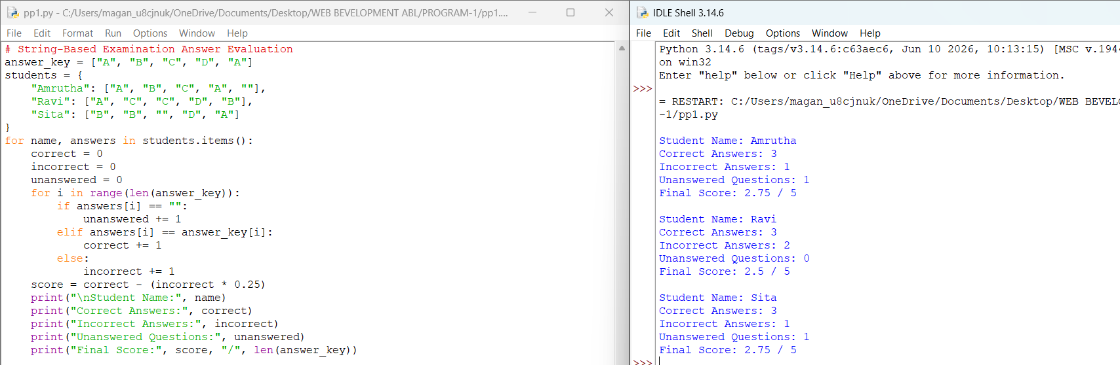
11. Conclusion:
Thus, the String-Based Examination Answer Evaluation program was developed successfully using Python. It compares student answers with the answer key, calculates correct, incorrect, and unanswered responses, applies negative marking, and displays student-wise results.

Experiment -9: University Admission Decision Engine:
1. Problem Statement:
To develop a Python program that evaluates candidates based on subject eligibility, aggregate marks, course-specific thresholds, and tie-breaking criteria, and generates a ranked list of eligible applicants.
2. Objectives:
- To evaluate candidates based on subject eligibility.
- To calculate and verify aggregate marks.
- To apply course-specific admission thresholds.
- To rank eligible candidates using aggregate marks.
- To use tie-breaking criteria when candidates have equal marks.
3. Assumptions:
- Candidates must score at least 60% aggregate marks.
- Candidates must score at least 50 marks in each required subject.
- The minimum aggregate for a particular course must be satisfied.
- Candidates with higher aggregate marks receive higher ranks.
- If aggregate marks are equal, the candidate with higher subject marks receives the higher rank.
4. Algorithm:
- Start.
- Store candidate details and course-specific thresholds.
- Read each candidate's subject marks and aggregate marks.
- Check subject eligibility.
- Check the aggregate and course-specific thresholds.
- Select eligible candidates.
- Sort eligible candidates by aggregate marks and apply tie-breaking criteria.
- Display the ranked list of eligible candidates.
- Stop.
5. Pseudocode:
START
STORE candidate details
STORE course-specific thresholds
FOR each candidate
CALCULATE aggregate marks
CHECK subject eligibility
CHECK aggregate threshold
CHECK course-specific threshold
IF all conditions are satisfied
ADD candidate to eligible list
END IF
END FOR
SORT eligible candidates by aggregate marks
BREAK ties using subject marks
DISPLAY ranked eligible candidates
END
6. Flowchart: Start → Store Candidate Details → Calculate Aggregate Marks → Check Subject Eligibility → Check Aggregate and Course Thresholds → Select Eligible Candidates → Rank Candidates → Apply Tie-Breaking Criteria → Display Ranked List → Stop
7. Python Source Code:
# University Admission Decision Engine
candidates = [
("Amrutha", 90, 85, 88),
("Ravi", 85, 80, 90),
("Sita", 90, 85, 92),
("Rahul", 70, 65, 68),
("Priya", 95, 45, 90)
]
course_threshold = 75
eligible = []
for name, sub1, sub2, sub3 in candidates:
aggregate = (sub1 + sub2 + sub3) / 3
if (sub1 >= 50 and sub2 >= 50 and sub3 >= 50
and aggregate >= 60
and aggregate >= course_threshold):
eligible.append(
(name, aggregate, sub1 + sub2 + sub3)
)
eligible.sort(key=lambda x: (x[1], x[2]), reverse=True)
print("RANKED LIST OF ELIGIBLE CANDIDATES")
rank = 1
for name, aggregate, total in eligible:
print("Rank:", rank,
"| Name:", name,
"| Aggregate:", round(aggregate, 2))
rank += 1
8. Test Cases:
Test Case | Condition | Expected Result
1 | Candidate satisfies all eligibility criteria | Candidate is eligible
2 | Candidate scores below the subject minimum | Candidate is rejected
3 | Aggregate is below the course threshold | Candidate is rejected
4 | Two candidates have equal aggregate marks | Higher total subject marks determines rank
5 | Candidates have different aggregate marks | Higher aggregate receives a higher rank
9. Sample Output:
RANKED LIST OF ELIGIBLE CANDIDATES
Rank: 1 | Name: Sita | Aggregate: 89.0
Rank: 2 | Name: Amrutha | Aggregate: 87.67
Rank: 3 | Name: Ravi | Aggregate: 85.0
10:Actual Output:
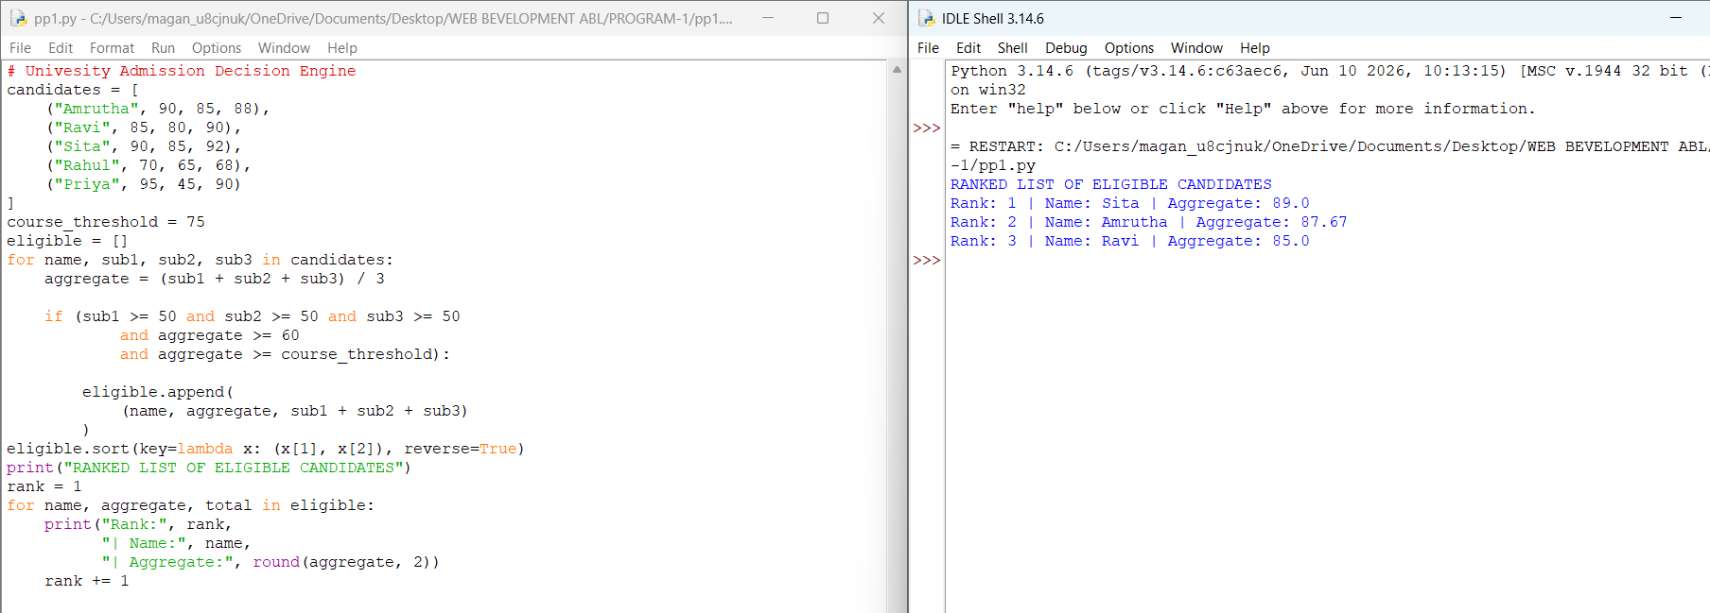

11. Conclusion:
Thus, the University Admission Decision Engine was developed successfully using Python. It evaluates candidates based on subject eligibility, aggregate marks, and course-specific thresholds. It also ranks eligible candidates and uses tie-breaking criteria to support a systematic and fair admission process.

Experiment-10: Multi-Stage Examination Eligibility System:
1. Problem Statement:
To develop a Python program that determines a student's eligibility for the final examination based on attendance, laboratory completion, internal assessment, and fee clearance, reporting every unmet requirement.
2. Objectives:
- To check student attendance eligibility.
- To verify laboratory completion.
- To evaluate internal assessment marks.
- To check fee-clearance status.
- To report all unmet requirements and determine final examination eligibility.
3. Assumptions:
- Minimum attendance required is 75%.
- All laboratory experiments must be completed.
- Minimum internal assessment marks required are 40 out of 100.
- All examination fees must be cleared.
- A student is eligible only when all four conditions are satisfied.
4. Algorithm:
- Start.
- Read the student's name, attendance, laboratory status, internal marks, and fee status.
- Check whether attendance is at least 75%.
- Check whether all laboratory experiments are completed.
- Check whether internal marks are at least 40.
- Check whether examination fees are cleared.
- Report every unmet requirement.
- If all conditions are satisfied, declare the student eligible.
- Stop.
5. Pseudocode:
START
INPUT student details
CHECK attendance
CHECK laboratory completion
CHECK internal assessment marks
CHECK fee clearance
IF any requirement is not satisfied
DISPLAY all unmet requirements
DISPLAY "Not Eligible"
ELSE
DISPLAY "Eligible for Final Examination"
Display the result
END
6. Flowchart:
Start → Input Student Details → Check Attendance → Check Laboratory Completion → Check Internal Marks → Check Fee Clearance → Identify Unmet Requirements → Display Eligibility Result → Stop
7. Python Source Code:
# Multi-Stage Examination Eligibility System
name = input("Enter student name: ")
attendance = float(input("Enter attendance percentage: "))
lab_completed = input("Are all labs completed? (yes/no): ").lower()
internal_marks = float(input("Enter internal marks out of 100: "))
fees_cleared = input("Are all fees cleared? (yes/no): ").lower()
requirements = []
if attendance < 75:
requirements.append("Minimum 75% attendance is required.")
if lab_completed != "yes":
requirements.append("Complete all laboratory experiments.")
if internal_marks < 40:
requirements.append("Minimum 40 internal marks are required.")
if fees_cleared != "yes":
requirements.append("Clear all examination fees.")
print("\nStudent Name:", name)
if requirements:
print("Status: NOT ELIGIBLE")
print("Unmet Requirements:")
for requirement in requirements:
print("-", requirement)
else:
print("Status: ELIGIBLE FOR FINAL EXAMINATION")
8. Test Cases:
Test Case | Condition | Expected Result
1 | All requirements satisfied | Eligible
2 | Attendance below 75% | Attendance requirement reported
3 | Laboratory work incomplete | Laboratory requirement reported
4 | Internal marks below 40 | Internal marks requirement reported
5 | Fees not cleared | Fee-clearance requirement reported
6 | Multiple requirements unmet | All unmet requirements reported
9. Sample Output:
Enter student name: Srija
Enter attendance percentage: 65
Are all labs completed? (yes/no): no
Enter internal marks out of 100: 35
Are all fees cleared? (yes/no): no
Student Name: Srija
Status: NOT ELIGIBLE
Unmet Requirements:
- Minimum 75% attendance is required.
- Complete all laboratory experiments.
- Minimum 40 internal marks are required.
- Clear all examination fees.
10:Actual Output:
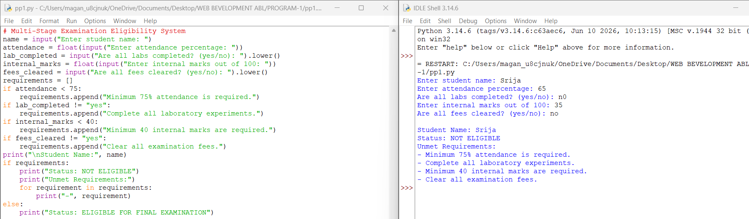
11. Conclusion:
Thus, the Multi-Stage Examination Eligibility System was developed successfully using Python. It checks attendance, laboratory completion, internal assessment marks, and fee clearance. It reports every unmet requirement and determines whether a student is eligible for the final examination.

